**Classroom Activity: Write a code to find one or multiple documents from the MongoDB collection.**

**Code: find one document from the MongoDB collection:**

FoodDelivery> // Find one document where the vendorName is "Delicious Bites"

FoodDelivery> db.vendors.findOne({ "vendorName": "Delicious Bites" })

**OUTPUT:**

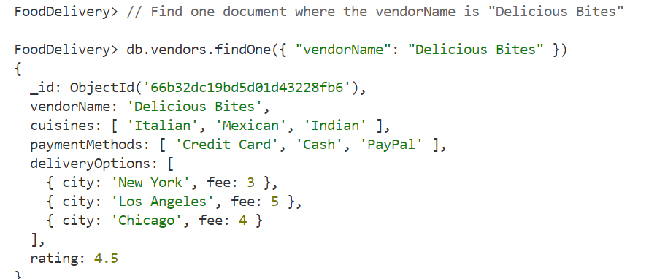

**Code: find multiple documents from the MongoDB collection:**

FoodDelivery> // Find multiple documents where the rating is greater than 4.5

FoodDelivery> db.vendors.find({ "rating": { $gt: 4.5 } })

**OUTPUT:**

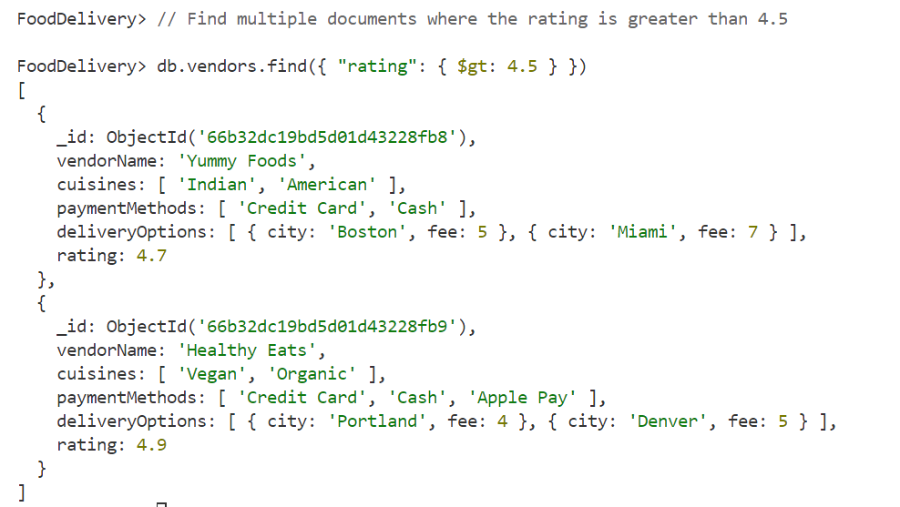

**Execution Steps:**

1. Install MongoDB compass and MongoDB shell
2. Create a new connection in MongoDB Compass
3. Create a new Database eg.)Food Delivery
4. Go to Visual Studio Code
5. Install the MongoDB for VS code extension
6. Click on the MongoDB icon on the navigation pane
7. Right click on the localhost:27017 connection
8. Select Launch MongoDB shell
9. Finally execute the above code.